Chrome Caching Fix
Please follow the instructions listed below to resolve issues with reports.cteis.com.
- Navigate to the problem website (reports.cteis.com)
- Select F12 or right-click and select Inspect. This should bring up the developer tools. *See example #1 below.
Example #1
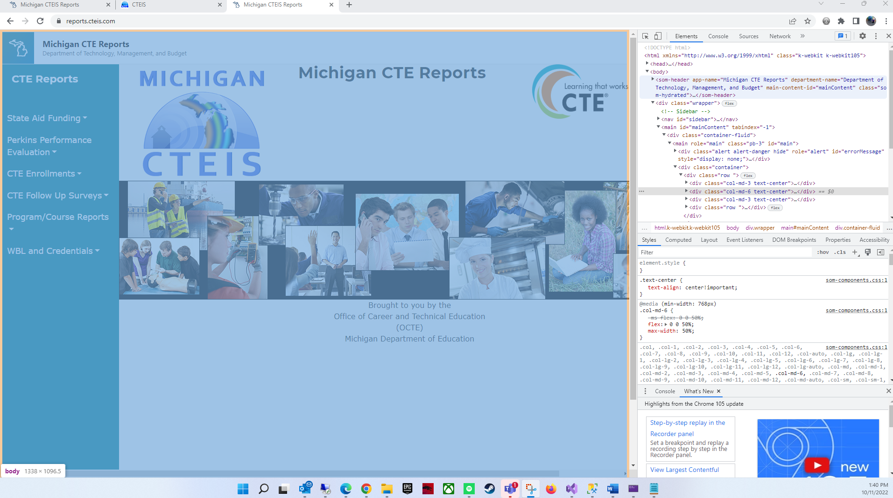

- The left side should show the developer tools. Select the application tab. You may need to click on the double carat (>>) to pull it up depending on screen size.
- The application developer tools should look like example #2. Select the Storage option on the left.
- Fill in the check box for “Including third party tools” then click on the “Clear site data” button as indicated in example #2.
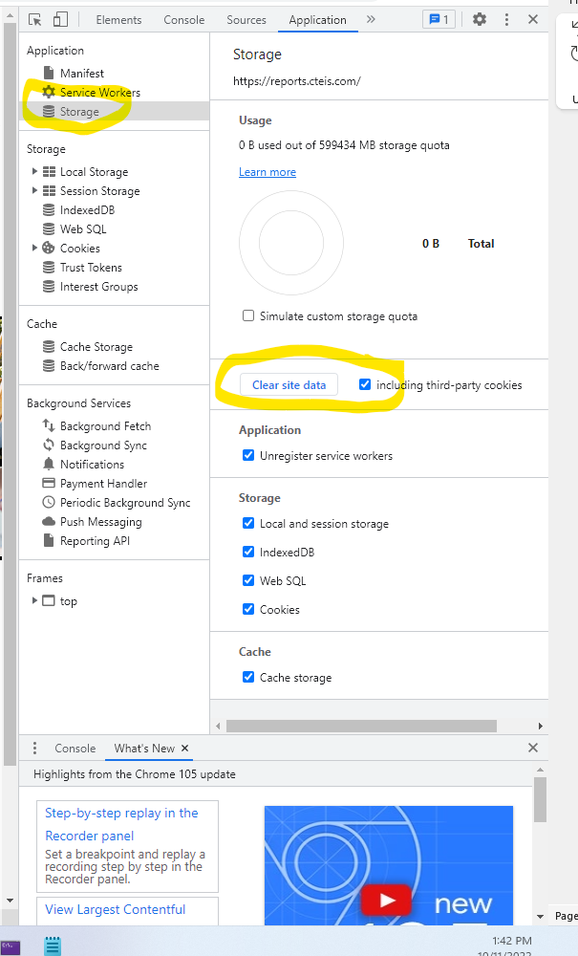
Example #2

- Close and reopen the browser, navigate to the website, and site issues should be resolved.

